Lab # 14

Working with Database in Visual Studio using Data Adapter and Data Readers.

DataReader

DataReader is used to read the data from database and it is a read and forward only connection oriented architecture during fetch the data from database. DataReader will fetch the data very fast when compared with dataset. Generally we will use ExecuteReader object to bind data to datareader.
To bind DataReader data to GridView we need to write the code like as shown below:
- Protected void BindGridview() {
- using(SqlConnection conn = new SqlConnection("Data Source=abc;Integrated Security=true;Initial Catalog=Test")) {
- con.Open();
- SqlCommand cmd = new SqlCommand("Select UserName, First Name,LastName,Location FROM Users", conn);
- SqlDataReader sdr = cmd.ExecuteReader();
- gvUserInfo.DataSource = sdr;
- gvUserInfo.DataBind();
- conn.Close();
- }
- }

DataAdapter

DataAdapter will acts as a Bridge between DataSet and database. This dataadapter object is used to read the data from database and bind that data to dataset. Dataadapter is a disconnected oriented architecture. Check below sample code to see how to use DataAdapter in code:
- protected void BindGridview() {
- SqlConnection con = new SqlConnection("Data Source=abc;Integrated Security=true;Initial Catalog=Test");
- conn.Open();
- SqlCommand cmd = new SqlCommand("Select UserName, First Name,LastName,Location FROM Users", conn);
- SqlDataAdapter sda = new SqlDataAdapter(cmd);
- DataSet ds = new DataSet();
- da.Fill(ds);
- gvUserInfo.DataSource = ds;
- gvUserInfo.DataBind();
- }

Step 1: ​Step 1 (getting Started)
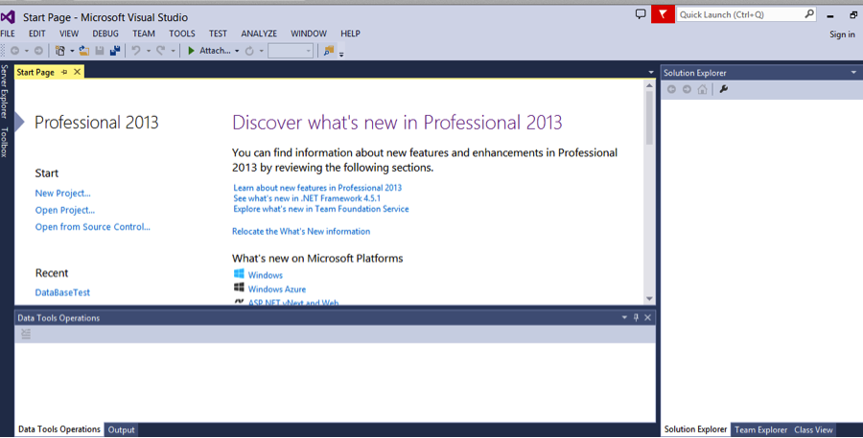
Starting up the Visual Basic App is the first thing we will do. While this step should be quite straightforward a is imperative that it is not rushed over; as getting used to the Virtual Studio setting will make this tutorial a lot easier. The start page will look something like this

Step 2: ​Step 2 (VS Project Creation)
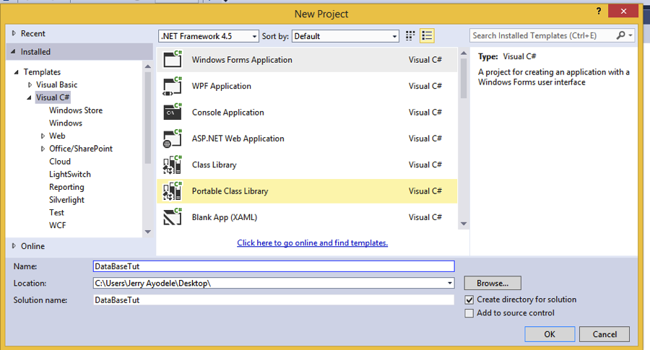
Things will start to get interesting now; we are going to make a new project in Visual Basic. Click on the File tab, under New select New Project where a window will appear. Under Templates choose the Visual C# section and to the right of that select Window Form Application, change the file name to something recognizable like DataBaseTut (Database Tutorial). If these steps have been followed you would have successfully created a project.

Step 3: STEP 3 (ADDING a LOCAL DATABASE)
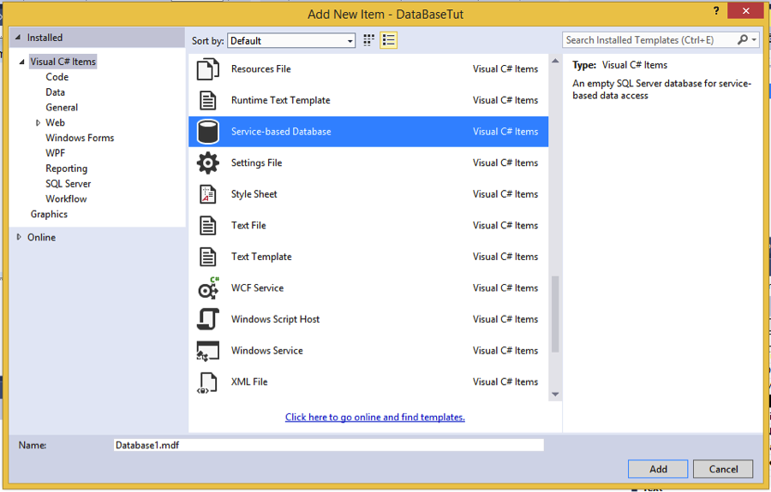
If as expected you have created the project your should now see the main page, complete with an empty smaller titled Form1 and the properties section on the right. Now we right-click the DataBaseTut tab on the right and select add new item, this window should appear:

Step 4: STEP 4 (SETTING UP THE NEW DATABASE)
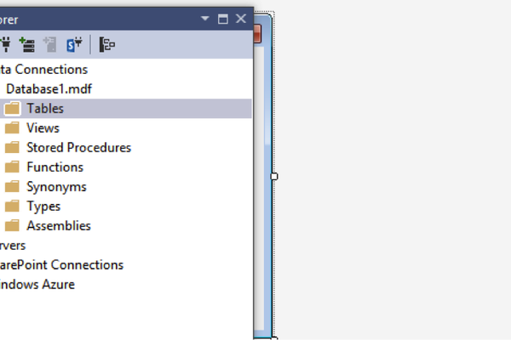
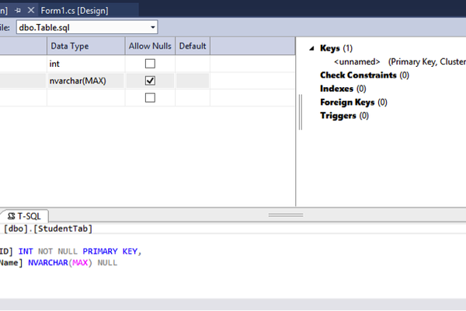
As you can imagine our newly created database would have no content, which makes for dull viewing. This next step involves creating tables for the database. We will use pretty generic values now but this is something that can be altered once you get a hang of it.
Now right click the Table tab and select add New Table option, the dbo.Table [Design] window will appear; this is where we will add tables. I will create two columns, specify what can be entered into them as well as rename the Table as StudentTab. After that the screen should look like this:
While you may have been successful in updating the database but it won’t show up on the main page, you will have to go to the Server Explorer then click on the database and the select Tables then hit refresh; this should fix the issue.
,Step 5: STEP 5 (EDITING THE FORM)
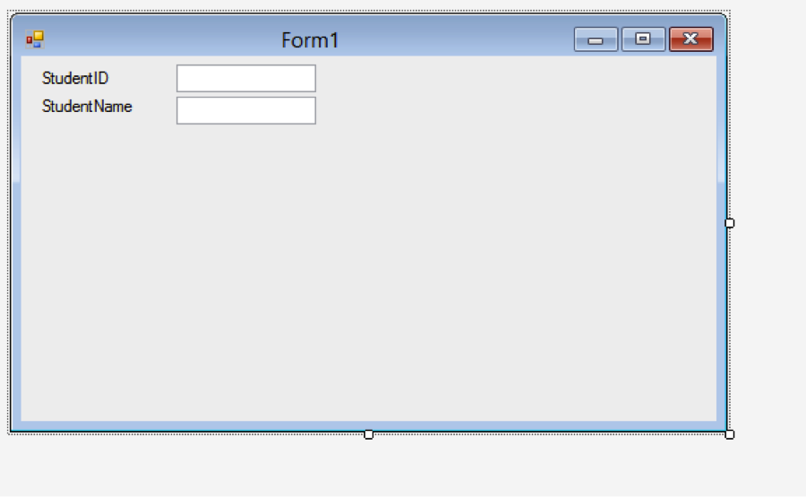
We will now work with the Form window on the main page now; this will serve as the main display for the database. Click the toolbox on the left of the screen and add a label to the form and alter the size to make the text readable, do this twice. These labels should be stacked on top of each other with the text in them being “StudentID” and “StudentName” respectively. Add textboxes from the ToolBox to the right of the respective labels as shown below:

Step 6: STEP 6 (MORE FORM EDITING)
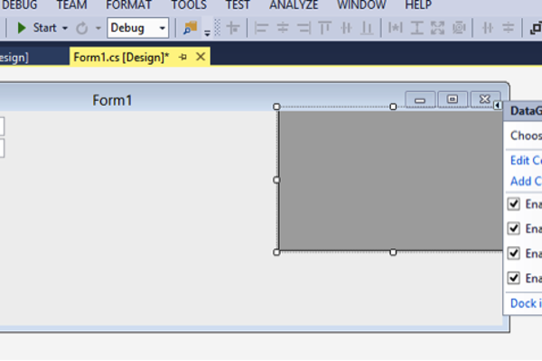
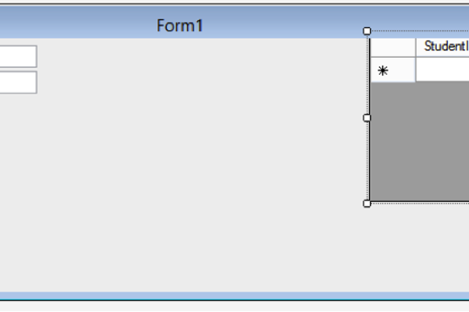
We are starting to make some real progress with the database and the form will be the access point for data entries in the database. We are going to add from the Data section of the Toolbox a DataGridView. Shift this newly opened window to the right, as I will do for organization sake. We will need to connect this grid view to a data source. The upper right corner of the grid view will pull up the window for this. The database we have made will be available to set up for this window.
After connecting the database the grid will display the info from our database:

Step 7: STEP 7 (EDITING THE GRID)
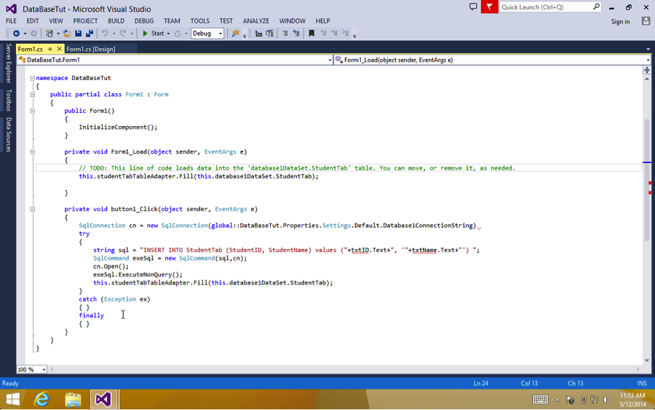
Now the framework for the buttons and functions will now be added; this will involve some coding that will be laid out pretty simply. The code should be as follows:

Step 8: STEP 8 (MORE CODE)
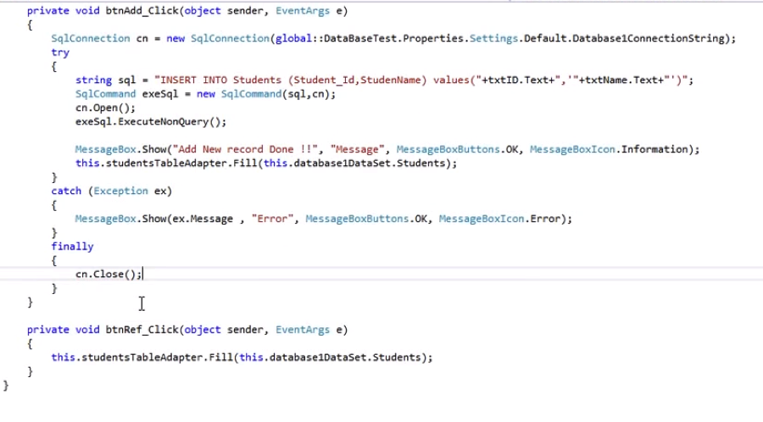
With
this program it is imperative that the code entered correctly; hence it taking two steps. Any slight variation will cause problems so the importance of code accuracy cannot be understated. Below is the complete code from the Form1.cs:

Step 9: STEP 9 (TRYING TO RUN YOUR CODE)
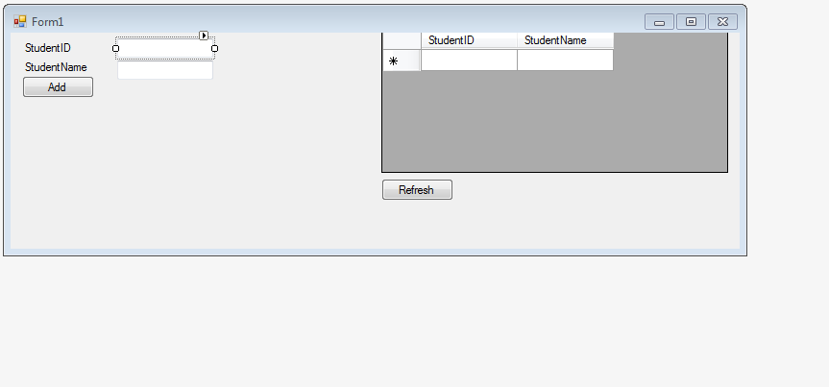
Now we get to test the code we have written. Here we should be able to add data to the database from the Form1 page:
If after clicking the Debug but the above picture doesn’t pop up it is likely that there is erroneous code somewhere check back in the Form1.cs page to make sure you have all the correct info.

Task
APPLY CONNECTIVITY IN BOTH THE FORMS USING DATABASES.
